CloudSolutions

HR Management System and Employee Scheduling

Justin Lazaro
Will Crawford
Ben Ross
Erik Steggal
Sabba Petri
Marlo Kertson
Alee Fong

Executive Summary
Millions of small and medium businesses (SMB) across the United States are using inefficient and legacy Human Resource (HR) management tools such as spreadsheets and messy paper-based systems. Businesses are also struggling with the management of complex employee schedules and often use complicated software or are manually creating schedules. Both of these issues are costing businesses millions of dollars and hours of time each year. At CloudSolutions, we are currently developing a cloud-based solution that addresses this issue. Today, HR management systems and employee scheduling exists as separate and isolated systems with no simple or easy way for them to communicate and work with each other. Our plan is to offer a solution that addresses these two common issues together as a singular, integrated system that’s easy for businesses of any size and type to use.
Our solution is a complete cloud-based human resource management system (HRMS) and an automated employee scheduler targeted toward small and medium businesses. We are offering a complete and integrated system that gives our customers the power and sophistication of enterprise-grade HRMSs, all in a simplified web interface. In addition to offering our hosted services, we will also provide unlimited data storage for both HR information and business-related documents. By utilizing the cloud-based model and providing our hosted services, as opposed to software solutions, we essentially take out the complexity of integration, the problems of maintaining it, and the cost of buying the equipment. To successfully build and implement this system, we plan on developing on one of the commercial cloud-based platforms such as Microsoft Azure or Amazon Web Services. Implementing on these platforms may potentially be a difficult obstacle for our development group to overcome as we will be required to learn the API and environment.
The CloudSolutions management team is comprised of a mixture of industry experience and undergraduate students. Justin Lazaro is the product lead and lead visionary for CloudSolutions. Will Crawford is our project manager and backend engineer. Ben Ross is our lead computer scientist and lead developer for our scheduler engine. Erik Steggall is our backend engineer and integrator. Sabba Petri is our lead user interface designer. Alee Fong and Marlo Kertson are the primary contributors for our marketing team, where they will be responsible for generating market research and designing business plans. .
Our goal is to provide cutting edge enterprise-grade software to a relatively untapped SMB market with the goal of helping them operate their businesses better, faster, and easier. We eventually seek to become the leader in providing sophisticated enterprise software services to SMB. We strongly believe that our HR SaaS (software-as-a-service) option is a great solution to an untapped market. We believe our diverse team of developers and marketers have the technology and business know-how to make this proposed company a reality. We are currently seeking funding to further development our cloud platforms, cover the majority of our logistical and operational expenses, and to market our product to customers.

Appendix
SWOT
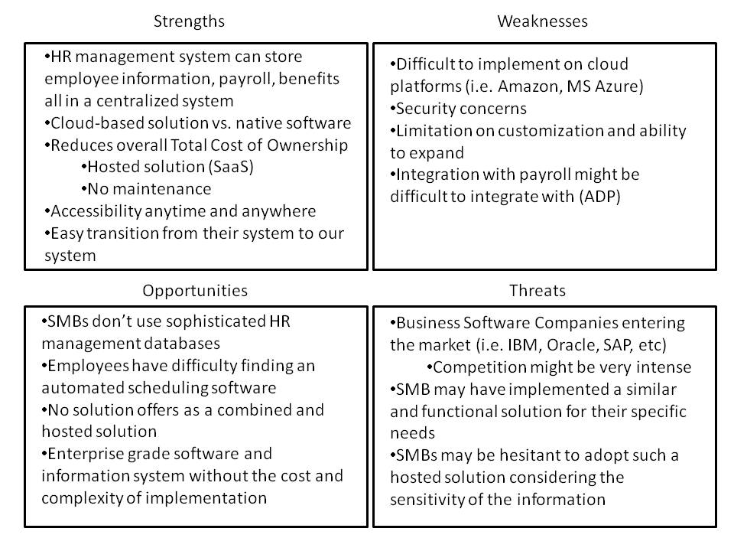
Team members:
- Justin Lazaro - Founder
  - Role: Team leader and product visionary
  - Background: Held internships at Hewlett Packard and Trend Micro in both marketing and R&D. Currently an undergraduate researcher in HCI. Senior undergraduate at UC Santa Cruz studying Information Systems Management and minor in Computer Science.
- Will Crawford – Founder
  - Role: Project Manager and backend engineer
  - Background: Held IT positions in a variety of web companies including Yahoo! Currently a senior undergraduate at UC Santa Cruz studying Computer Science.
- Benjamin Ross - Founder
  - Role: Chief Scientist
  - Background: Held QA position at WAN optimizer company RiverBed Technologies. Currently a junior undergraduate at UC Santa Cruz studying Computer Science.
- Erik Steggall - Founder
  - Role: Backend developer
  - Background: Currently a senior undergraduate at UC Santa Cruz studying Computer Science
- Sabba Petri – Founder
  - Role: User interface designer
  - Background: Currently a senior undergraduate at UC Santa Cruz studying Art History and Computer Science
- Marlo Kertson
  - Role: Marketing
  - Background: Currently a senior undergraduate at UC Santa Cruz studying Business Management Economics and minor in Information Systems Management
- Alee Fong
  - Role: Marketing
  - Background: Currently a senior undergraduate at UC Santa Cruz studying Information Systems management

